The Object Who Knew Too Much
Donald Kunze

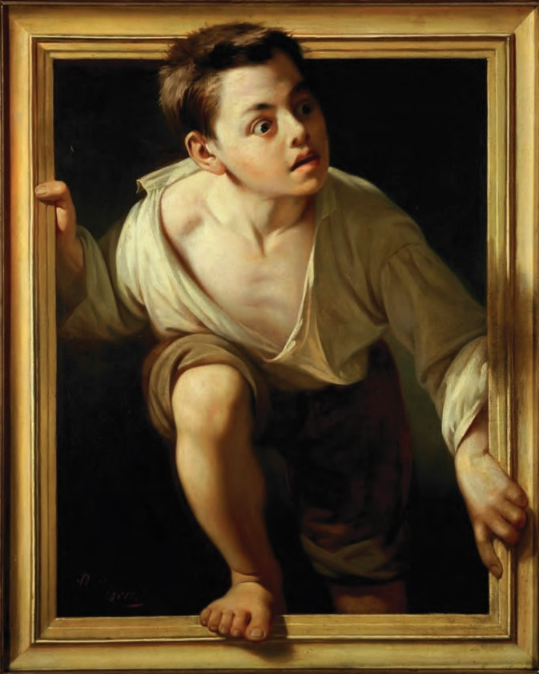

Pere Borrell del Caso, Escapando de la crítica (Escaping Criticism), 1874.

The painter's products stand before us as though they were alive, but if you question them, they maintain a most majestic silence. It is the same with written words; they seem to talk to you as if they were intelligent, but if you ask them anything about what they say, from a desire to be instructed, they go on telling you just the same thing forever [emphasis mine].
——Plato, Phædrus, 275d

When objects speak to us, they engage poetic mentality that uses frames and exchanges across frames to construct a “boundary language.” Modern rhetorical theory generally assigns such actions to the figure of ekphrasis, but a more specific definition is needed. What is inside the frame “signals” to us in a conventionalized way; but passage across and within framed spaces must shift to a new channel of communication. Although the art object must travel along smugglers’ trails by night and use special codes to “signalize” to us, the subjects–who–see, this signalizing constructs new channels in space and time. The covert message cannot be experienced in a detached way. The object in art engages the subject in sheer immediacy. This is the power of ekphrasis.
We can imagine a shamanistic origin for this “here and now” function, where natural and specially constructed objects are empowered to speak a voix acousmatique, in codes and channels designated as permanently authentic. We already allow that art has a basic, native ekphrastic power: after all, poetry is sung to the heart, architecture is, naturally, architecture parlant. Paintings travel straight to our emotions, pausing only slightly to say that they might resemble something. The art object does not simply convey an artist’s intent. The object itself has “grabbed the microphone” so to speak, reverting to the magic function of the animus of the natural object, invested by the mythic mentality as the font of divination.
As with Borrell del Caso’s Escapando de la crítica, what should be merely a representation, symbol, or metaphor steps out of the frame to speak directly to our desire or fear. Galateia hops off Pygmalion’s pedestal. Pinocchio casts aside his stringware.¹ Things speak for themselves, gain autonomy, find a voice.² Art may teach them how, but the physics and economy of this transformation from death to life is funded by magic, and it is essential to begin any study of the emotional functionality of objects with a review of a logic of magical exception. The basic rules may be stated in terms of a role-reversal of subject and object. This begins when a privation, negation, or lack assumes a positive existence. When the absence of light is reified as darkness, it assumes power and independence. It becomes not just an absence but an antipode to light. Just as famously in culture, the lack of good is reified as evil, fully autonomous with its own powerful devils and domains. In this dynamic predication reversal, objectivity is not simply a privation of subjective being; it acquires polarized being. It is no longer a margin or limit of subjectivity but a center standing opposite subjectivity, radiating its own dark power in counterpoint. Thus, when negative qualities are reified, negation itself is carried into the new positive formation. “Nothing” becomes nothing-ness. As Sartre famously parodied in Pierre’s failure to keep his appointment, “Pierre is not here in the café” is not a simple case of a forgetful person, but a positive force that is not sitting at any table, not waiting for anyone to come.³
Darkness is as much as light is, and in taking up this negative scepter it assumes the powers that were always waiting for it — a realm, no longer a margin of defeat. The moment of this assumption is key. “Retroaction” is the temporality of ekphrasis. In retroaction we arrive at a future that is at once a simultaneous past. The present becomes the fusion of a moment of “pure sensation.” As in the dramatic moment known as anagnorisis, where what has been known all along rushes forward into a new formation of meaning, we experience a déjà vu, a short-circuit, a defect in the normative temporal line that has opened on to infinity.⁴
When we investigate object autonomy in architecture, we must rely on literary, philosophical, and even shamanistic traditions. Personal experience, too, is significant. The experience of pure sensation in the future/past retroaction of reversed predication, object becoming subject, is not just an exception, it is the kernel of our most intensive states of meaningful being. I propose to adopt a framework that is natural to the object–subject reversal, a framework that not only applies to its elemental nature and history but employs the same logic of the “binary signifier” that characterizes much of contemporary research. This is the early 20c. psychologist Ernst Jentsch’s designation of the
“root conditions” of the uncanny, recognized by Sigmund Freud in his classic study of the subject.⁵ Jentsch both accepts and transcends the logic of the binary signifier. Beginning with the primary opposition of life and death (in which we may see, prefigured, the opposition of subject and object), Jentsch sees the uncanny as a signifier “occulted” for either the left–hand or right–hand term. In life, he argues, there is always a minimum element of death, operating as fate that draws the living subject to a pre-determined end. And, as if in ironic symmetry to this power within life, there is within death a similar minimum element, this of life, which sustains the dead soul in a kind of suspended state until, after a set of trials and wanderings, it finds a final rest (Fig. 1).
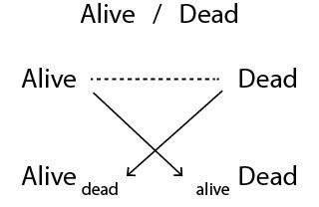
Figure 1. The uncanny’s primary conditions A_{D}, D_{A}, as constructs of cross inscription of the binary signifier, “alive versus dead.”

Jentsch might have abbreviated these conditions thus: A_{D}, for life drawn to death; and D_{A}, for the subject that “has forgotten how to die.” Mythology, folklore, and even modern literature are replete with examples of both categories. For A_{D}, there is the famous Appointment in Samarrah, novelized in 1934 by John O’Hara. The logic of this plot is that the subject who flees death does the very things that are required to reach death’s exact location. Freedom is revealed to be an illusion. Every choice is a “forced choice” that has only one direction: the end. The imagery of D_{A} is equally famous: the closed/curved labyrinth through which the soul wanders (errare) until, after the completion of required trials or punishments, it is allowed to rest. The evident architecture of D_{A} offers the main clue, that life, where freedom is an illusion required to establish the certum of a final destination, is nothing more than the obverse of death, whose freedom to wander is replaced by a canonical series of obstacles preventing any final rest. Wandering is key to both the designs of life and death: there is the illusion of choice but choice is, perversely, a fixed game. As in Giambattista Piranesi’s famous series of fantastic prison scenes, the Carceri, we can go anywhere we like because anywhere is eventually the nowhere of infinite space within a finite boundary. A final destination is final in simultaneously spatial and temporal terms, allowing us to reverse the predication to see how space and time might, in their essence and autonomy as extended, might themselves be “final” (especially Kant’s sense of finality or purposiveness); and how this finality might be related to a specific, concrete placement, a destination.⁶
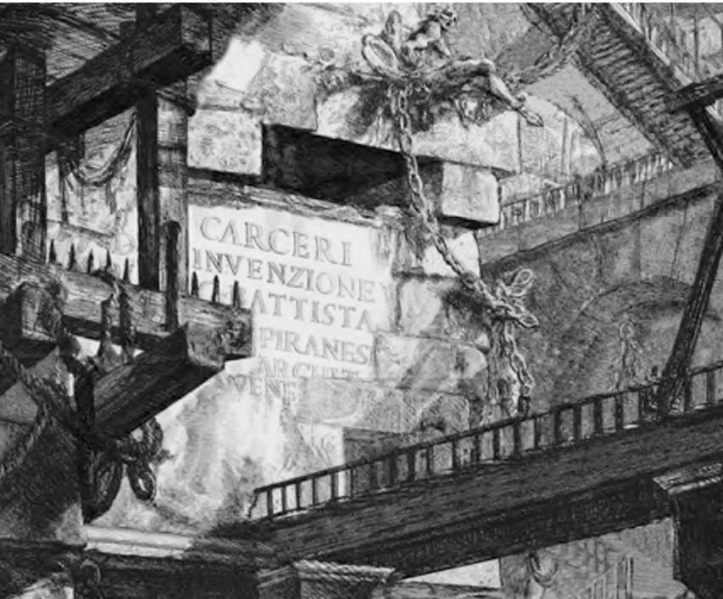
Figure 2. Title plate, Carcieri, Giambattista Piranesi, 1745–1761.

The designation of Jentsch’s formula of “cross inscription,” where death penetrates life as life’s “tell” and vice versa, is not simply a method suggested to crack into the boring impasse of the binary signifier. What works for life and death also applies to subjects, presumably animated, and objects, presumably “dead” by comparison. This relation is compacted into Giambattista Vico’s description of the animus and anima of the Stoics.⁷ Where nature is “passive” as feminine anima, its life comes from penetration by a male animus, or mind. As sexist as this may sound initially, its truly radical feminist position is evident when Vico describes the cœlum, an ancient Latin word, as both “heaven” and “wedge.” The etymological connection is clear, he says. The animus of wit/mind penetrates “passive” matter to give it sense and mortality, but the key is how the animus/wit of Vico is already an “occulted signifier,” giving it the very qualities of anima that allow it to find its basis within anima, a matrix (womb and field) as its final domain. Just as Jentsch’s cross inscription converted the binary of life and death into A_{D} and D_{A}, Vico’s wit is wit only in the act of occultation. Using “masculine” (M) to designate animus and “feminine” (F) for anima, we might write: F_{M} → M_{F}. Just as death is not death until it finds its place as the “occulted term” within life’s apparent free choices, the animus of wit is not witty until it finds itself within the readiness of materiality.⁸
We might as easily attack the binary signifier from the opposite side. By saying that “materiality is not material unless it appears as a kernel within the center of subjectivity” we face directly the idea that, within subjectivity, there lies a radical objectivity, an automatism. We might think first to identify this kernel as the site of interpellation, the inscription of authority within a void at the center of human subjects who, unable to identify the source or meaning of an authority, create an enigmatic blank that operates as an imaginary Other.⁹ Louis Althusser’s policeman, who shouts “Hey you!” to pedestrians crossing the street, each of whom believes him/herself to be the object of the shout, is the famous paradigm–exemplar. Because authority’s aim is impossible to locate, subjects must settle the matter subjectively, personally. The result is the “objective subject” of ideology who voluntarily responds to enigmatic orders from above.
Another case of material subjectivity is the Freudian Thing, Das Ding; the only difference is that we have discovered this key principle without having first to go through the agony of dream theory, developing then abandoning the pleasure principle, and discovering the unconscious. Voilà, we might say, here is the essence of subjectivity: its objectivity, its automatism; just as the mirror condition, animate objectivity, proves that binary signification does not segregate opposites but reveals a dynamic (Hegelian) dialectic process — a process owed to occultation.
After seeing that the symmetrical conditions of object and subject establish not a logic of binary signification but, rather, a condition of cross inscription of each into the other, the question becomes, “What is occultation?” If occultation holds the keys to Vico’s conundrum of animus and anima, bound up within the mystery of “argute,” wedge-shaped wit; and if it maps the landscape of the uncanny in a single formula, it is well worth our effort to rephrase the question of the “speaking object” so that the F_{M} of anima is also the “heavenly wedge” of animus that we can document in all its historical contingency. Evidence comes freshly to hand: the practice of divination, a subject in which Vico put so much store, as the “first science” by which humans, in seeking to settle the vibrant variations of nature into a certum, a “certain order,” of signs, established a root institution that could give rise to all others: laws, religions, arts, and sciences.¹⁰ Not only does F_{M} designate the essence of divination, where an object is “sacrificed” (stopped in its temporal tracks in order to record the synchrony of parallel realities), it shows how the complementary condition, M_{F}, places within this prophetic voice a certain mechanism that all ancient cultures seem to have discovered, from the 64 cross interpolated hexagrams of the I Ching to the designated positions of the horizon set out by Hopi mandalas. The evidence is clear: the binary signification of object–subject fail to yield watertight categories whose polar oppositions afford interior compromises and balance points. Rather, the very distinction of object and subject lead directly to the reality and matter-reality of occultation, the logic of divination. This can be paraphrased as “what is to be found is that which first must have been hidden, and hidden with the intent of depriving the mind of essential truth.”
In other words, occultation is the process by which humans see the world as “more than meets the eye,” and this “more” is the basis of a virtuality built in to every perceptual and imaginary experience, waking and dreaming. This goes beyond the mechanical virtuality by which we imagine full three-dimensional objects behind the one face we see directly. It is the anticipation of a future as well as memory of a past. It is the inclusion of hypothetical realities based on anxieties or desires. It includes impossible as well as conventional ways by which space and time achieve their illusions of continuity. Occultation makes human perception different from animal perception in the following way. Animals are experts in seeing beyond simple appearances; they seem to have their own virtual fields and extensions. Human perception is, in comparison to animal perception, defective. It seems to rule out the intuitions developed through experience and instinct. Vico opines that, in a hypothetically universal moment of intense fear, the first humans lost this intuition in a destructive overload — his anecdotal reference was an extended loud clap of thunder so intense that it was indistinguishable from a loud human-like shout, indecipherable but nonetheless intended as a warning or admonishment. “Signalizing” meaning without being decipherable, this thunder seemed to conceal secrets of great value; but within this primary occultation was a truth hidden even more deeply — that humans had projected their own nature into this shout but renounced their authorship so radically that the thunder was conceived as the voice of a god.
Vico condensed this logic into what he called the central discovery of his life: the “imaginative universal.” The result of this projection of inner human nature to the objects of the natural world was, in terms of the Jentschian uncanny, D_{A}, the “inanimate object” whose inner (demonic) essence is horrifyingly but gnomonically alive. Unable to communicate as a sign, nature–as–telic became enigmatic. Its secrets could be pried out only through ritualized divination. These rituals were required for, and gave rise to, the central events of human life proper, marriage and burial. Their fortunetelling function gave rise to sciences that were at first religious, later secular. Their rulings on social transgressions gave rise to laws and the concept of justice through res publica, literally, “the public thing,” the object–thing with a radically interior kernel of demonic subjectivity.
Once we make the connection between occultation and the process of framing, we can see how ekphrasis, the rhetorical logic of the frame that also includes the il-logic of violations of the frame, is key to the cross inscription process that makes human mentality fundamentally and generatively uncanny. Objects speak using this (il-)logic, and in speaking they show us the way to the mysteries of (1) cathexis, the process by which the psyche invests emotion and animus into the external, objective world; and (2) epiphany, the process by which the external objective world returns a value greater than the original investment. The payoff of the Jentschian uncanny here is this: we see that the original terms of any binary signifier are abstract and “nothing more than signifiers” until they undergo the process of occultation where, by appearing as hidden elements within their “opposite’s domain,” they acquire value as a Real, a traumatic remainder that, under the heading of Lacanian jouissance, they persist, endure, and in-sist, pushing their way into dreams, fantasies, and everyday experience.¹¹ This gives us the road-map we need to say how it is possible that everyday objects are “things that know too much.” And, like Bob Lawrence in Hitchcock’s 1934 film, they “do not know what they know.” This puts a permanent seal on the enigma of the object, whose speech, like the thunder’s, remains radically enigmatic.

Defects in the Signifying Chain: Citizen Kane
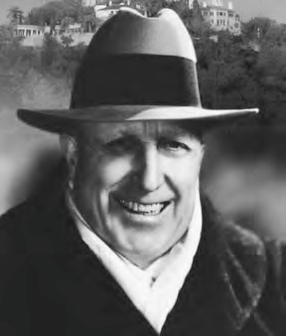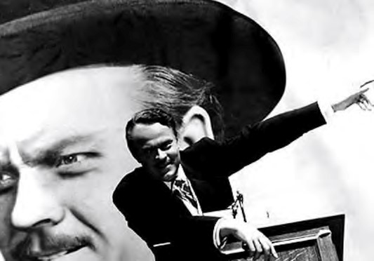
Figure 2. William Randolph Hearst and his fictional double, Charles Foster Kane.
The road-map Jentsch makes possible through the introduction of the “occultation solution” to the impasse of the binary signifier gives us an upside-down idea of what is real and what is not. From life’s standpoint of subjectivity, death is unimaginable; yet, through occultation, we arrive at Heidegger’s claim, that life is a “being–toward–death,” in a rather direct and unusual way. Death is never more real than as an animalistic center — not just a peripheral, temporalized limit — from within life’s pleasures and pains. In complement, death becomes life’s objective mirror image. Behind un-emotive façades it speaks through a demon (apophrades is the Greek correlate), whose emergence is traditionally keyed to points of the calendar or places in the landscape that are “openings to Hades.” From these openings, death’s demon sends out enigmatic, garbled encryptions that, although they seem to say something, refuse translation into any spoken idiom.¹² Thus we have life–in–death and death–in–life, no longer a polar opposition of two unknowable abstractions but two corporeal and completely Real bodies whose shadows rule as Psyche — although we cannot say from which domain, life or death, we are able to make this claim.
Jentsch’s “method of uncanny cross inscription” shows how reality and fiction mingle on a daily basis. We know this as a generalization, of course, but the method gives us a way of forming specific propositions to test and corroborate. In effect, we require a way to push what we find to be the “structural necessities” of a binary relationship to see if they have historical reality. The relation to the binary structure and occultation should, in turn, offer new insights and reveal hidden meanings. This is a forensic operation that can be compared to an archaeological site analysis; but the sites in question are “sites of exception” — points in the signifying chain that are flawed or malfunctioning, points where fantasies constructed to mask the defects give way to a volatile Real.
Such a site is offered up by the famous case of Citizen Kane, Orson Welles’ 1941 film, satirizing the media magnate, William Randolph Hearst. Hearst owned newspapers, film studios, mines, and extensive real estate. He was a magnate in the fullest 20th century sense: a wheelerdealer who stopped at nothing to gain control and expand influence. Welles at the time was known mainly for his disastrous Halloween spoof, dramatizing H. G. Wells’ War of the Worlds to scare a 1938 radio audience out of their wits. In Citizen Kane, Welles planned a different kind of terror, that of “getting the goods” on a powerful figure by setting up a mine–field that Hearst could not cross. Hearst, known for inventing sensational stories, found himself a victim of Welles’ own sensational fiction.
Hearst and Welles form a particular kind of binary signifier. On one hand, Welles is the antipodal rival of Hearst, getting publicity out of a mocked-up simulacrum of “he whosename shall not be spoken.” On the other hand, Welles is, as a creative artist, at one end of a pole constructed by wealth, whose alternative names could be power/art, wealth/desire (for wealth), master/servants. This latter polar signifier is the most relevant to Hearst. It was materialized by Hearst’s magnificent “castle,” the mansion Hearst called “La Cuesta Incantada” (the Enchanted Hill, literally the hill “sung into being”) at San Simeon, California, between Los Angeles and San Francisco. Here, artists, mostly film stars, were invited for lavish weekends of dining, dancing, and romance in the mansion’s maze of garden spaces and rooms furnished with architectura di spoglie bought in Europe and shipped to the site. The architect, Julia Morgan, spent twenty-eight years building and rebuilding the castle to meet Hearst’s continually updated fantasies. The goal was clearly not to create a historical simulacrum but to provide settings for interactions among the guests.
“Occultation” plays a key role no matter how the binary signifier is construed. For the power/art construct, occultation is provided architecturally by San Simeon’s labyrinthine spaces, hallways, and garden paths. For Welles’ parody, Kane/Hearst, occultation is the key theme: what was Charles Foster Kane really like? How did the clue, his last word, “rosebud,” fit in the picture? Rosebud could be said to be a doubly occulted signifier. In the film, it leads the audience to believe that the young Kane, in giving up his childhood sled when he was trundled off to boarding school, had sustained a primordial loss of maternal affection. Only at the end of the film do we see the word “Rosebud,” painted on the sled as it is tossed in the incinerator. But, Welles was vicious in this choice of words, employing the rumor that rosebud was Hearst’s nick-name for his famous mistress’s clitoris.¹³ Marion Davies was ruthlessly caricatured in Citizen Kane, interviewed early in the film as a down-and-out nightclub floozy. Hearst must have found the sting unbearable. Rosebud locked his ire into a self-defeating conundrum. If he admitted its real meaning he would be further humiliated, and any attacks on Welles would lead to the meaning of rosebud. In other words, the signifier really did contain the secret of the real-world magnate!
To make best use of the idea of the binary signifier, it is best to see how its horizontal polarized line is a picture of subjectivity through the lens of ideology. Our diagram is not an abstraction. The diagram is already present as a structuring principle. The binary is a binary of subjectivity split by mastery: two competing masters (Welles/Hearst), masters and servants (the art/power dynamic of Hearst Castle), or victim and image of parody (Hearst/Kane). Mastery is a utopian goal realized only in imagination, by an “ideal ego” (Ideal-Ich) projected from symbolic relationships. This ideal holds the chain together by seeming to embody its limit as a target set for others that can never be achieved by one who is simultaneously a model and an exception. Hearst easily fits this definition, and his combination of model and exception is exploited by Welles when he depicts Kane as one who breaks the very rules he imposes.¹⁴
Split subjectivity is rivalry of the kind made famous by Réne Girard in his many treatments of this theme in folklore, politics, literature, and art.¹⁵ Two masters are a contradiction; one must go; a “fight to the end” is inevitable. The battle between competing masters thus has a central, general role to play in subjectivity as a whole, at all levels. Subjectivity in general can be said to have this selfsacrificing aspect. At the level of the individual it is the suppression that creates an unconscious. At a more general level it is the “remainder” of the subject that is not fully commandeered by ideology, a remainder that, by creating fantasies, is able to tolerate subjugation by ideology, able to function by having some positive existence through fantasy (Lacan’s Imaginary). In the Welles/Hearst rivalry, there are two significant structures that could be regarded as “left-hand” and “right-hand” versions of a single reality. This reveals a central truth about all subjectivity: that it is chiralistic, or “handed”; that in any polar construct, either pole can be considered to be dominant, throwing the other pole into a passive, reactive mode.

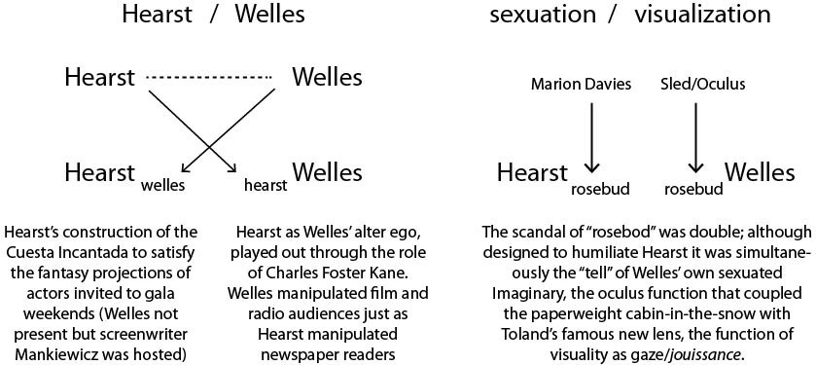
Figure 3. The Hearst/Welles binary signifier expands to expose the telltale detail coupling the occulted signifier, “rosebud,” with the optical over-exposure of Hearst’s biography.

Where, for example, Hearst dominates Welles as any industrialist might be said to dominate artists who must work for a living (in the very industry over which Hearst exercises great control), Welles must sublate himself as “Kane,” the fantasy formation that allows him to survive Hearst’s overwhelming ideological control.¹⁶ And, when Welles gets the better of Hearst with his use of the scandalous name Rosebud, it is Hearst who, in the victim position, is brought face to face with his own fantasy embodiments, Marion Davies’ genitals, elaborated into the architectural complexities of La Cuesta Encantada at San Simeon. The other interesting result of cross inscription is the fundamental occultation of depth through Gregg Toland’s unique camera lens, allowing the enfilade of foreground, mid-ground, and background to bend around narratively within single tracking shots.¹⁷
At the power end of the binary, we see two kinds of ideal egos projected to conceal defects in the signifying chain. The first is the historical figure of Hearst himself as a mysterious figure who, at San Simeon, appears and disappears suddenly. This is the essence, Lacan argues, of the phallic — inexplicable alternation between visibility and invisibility. Although it was rumored that he used a system of secret passageways and hidden doors, there are actually none. Hearst would use events strategically, knowing when and where to appear and how to circulate among his guests, when to retreat to his study upstairs to stay in phone contact with his many newspaper and other interests. As an alternative ideal ego projected out of the Imaginary, a mysterious “real Kane” is hypothesized by reporters who want to follow up the rosebud clue after Kane’s death. This “famous last word” leads them on a forensic chase that is the spine of the film’s plot, unanswered diegetically but provided as an image of a burning sled in the film’s last seconds.¹⁸
The two versions, left and right so to speak, combine to create a polysemous reading of Citizen Kane in relation to the real-life William Randolph Hearst, an Ideal-Ich, or superego figure. The left-hand sublation of Welles into Kane pairs with the right-handed sublation of the real Hearst, humiliated by the exposure of the meaning of rosebud. The left-hand Hearst as an enigmatic host popping out of the woodwork of La Cuesta Incantada is overlain with the Ich-Ideal of the “real Kane,” the object of the film’s quest.¹⁹ This quartet of alternating elements meets in a central “anamorph,” where it is impossible to say which is more actual, the fictional Kane or the actual Hearst. This anamorph is itself a “secret passageway” such as that rumored to exist at San Simeon, for it shows how occultation has, in providing a way out to the defects of the binary signifier, has opened on to an unpredictable wealth of signification, a “treasury” that could be said to embody the mass of stolen goods depicted in Citizen Kane as the camera pulls out slowly (before the burning sled scene) in a crane shot that beholds a vast room filled with art stolen/acquired from European churches, villas, and cities. Mirroring the boom shot in the opening scenes that takes us to a match-frame of the window in Kane’s bedroom, this pull-back reveals multiple layers of meaning, uncorked by the simple merger of fiction’s left hand with reality’s right.
As per Jenstsch’s predictions, the “reality terms” (Welles and Hearst) constitute a defective symbolic contrast. There is really no continuum, no ideality, no completely dominant ideology. However this chain of signifiers is maintained by the occulted terms that, projected chiralistically in left- and right-hand versions, acquires a reality that is “more in them than they themselves.” The Welles/Hurst (W/H) binary becomes Wh/Hw when “little hearst,” Kane, is constructed in Citizen Kane and when “little welles” is impishly inserted as a double-edged reference in the name of a child’s sled. The binary is not resolved by its left- and right-hand occultations, but it is shown the way to anamorphic constructs that materialize the full range of significations within single sequences. One such is the match-frame taking the viewer from a long crane shot closing in on the exterior of the bedroom window to an interior shot of the same window, reversing inside and outside as interior light becomes the early light of dawn. The frame, Lacan generalizes, is the essence of the uncanny: “… [T]he dreadful, the shady, the disturbing, everything by which we translate … Unheimliche, presents itself through little windows. The field of anxiety is situated as something framed.”²⁰ Anxiety is thus not the condition of fear where the object of fear is the most remote but something where distance has been collapsed in a topological way, “through a back door” — namely, through cross inscription of the kind Jentsch demonstrates in Ad/Da.
Another key anamorph follows close on: the crystal paper-weight released by Kane’s dying hand. When it shatters on the floor, it becomes a “gnostic jewel” opening on to the diegetic story of Kane’s life in retrospect. The lens has multiple meanings. It is an oculus containing a cabin in a winter scene. Again, the matched frames of the paperweight miniature and the actual scene in Kane’s childhood home in Colorado open a series of flashbacks opens up the linear line of time to recover key scenes and explore realities that would have been impossible to witness from any one point of view. The oculus shows us not just the relations linking these scenes, but the idea of the film itself. Indeed, the film’s visual structure owed to the invention of a special lens by Gregg Toland, the cinematographer. This lens allowed Welles to shoot scenes through an enfilade of rooms, keeping in focus many details of the background while a foreground was revealed as a “present” to the “past” left behind in the distance. The paperweight and Toland’s lens constitute a single optical idea of the binary signifier though the de-occultation of distance.

- My hunch is that all such frame-bounders are forms of Mary Shelley’s Frankenstein monster, inanimate stuff that has acquired autonomy through a combination of technē and magic. Re-reading Shelley in light of ekphrasis sheds light on the monster’s ability to prophesize. Also, his tendency to melancholia is more understandable as a migrant’s sadness in traversing the borderlands between life and death, generalizable to all such travelers.
- Artists often take advantage of this to create a “detached virtuality” by violating the conventional frame of fiction. In Locos: A Comedy of Gestures, Filipe Alfau invents a character who, dissatisfied with the role Alfau has assigned him, waits until the author has left to answer a knock on the door to escape his assigned plot duties and seek other adventures (New York: Farrar & Rinehart Inc., 1936).
- Jean-Paul Sartre, Being and Nothingness: An Essay on Phenomenological Ontology, trans. Hazel Barnes (New York: Philosophical Library, 1956), 9.
- Henry W. Johnstone, Jr., “Truth, ‘Anagnorisis’, and Argument,” Philosophy and Rhetoric 16, 1 (1983): 1–15.
- Ernst Jentsch, “Zur Psychologie des Unheimlichen,” Psychiatrisch–Neurologische Wochenschrift, 8, 22 (August 26, 1906): 195–198 and 8, 23 (September 1, 1906): 203–205. Sigmund Freud, David McLintock, and Hugh Haughton, The Uncanny (New York: Penguin Books, 2003).
- Extension is the essence of non-finality, a pure a “pulsion” extending from an imaginary causal point to an equally imaginary infinity. Curvature qualifies or contradicts this freedom by revealing a distant point that serves as a center of a slight arc that, if the line continues, will return to the point of origin. In this imaginary physics of space-time travel, any return or repetition implies the bending of a formerly straight, infinitely extended, line related to a distant gravitational center point regulating the precision of the return. However, this precision is entirely contained within the line itself, as a crisscross exchange of goal for aim. In this binary signifier, the goal is distant and the aim proximal. “The circuit of the drive is perhaps best defined as the pulsation between goal and aim: initially, the drive is on the path towards a certain goal; subsequently, this goal coincides with the experience of the path itself, whose ‘aim is nothing else but the return of this circuit’ — in short, the true end (‘infinite’, aim) achieves itself by traversing its incessant failure to achieve the ‘finite’ end (goal); in the very failure to achieve our intended goal, the true aim is always already achieved.” Jacques Lacan and Jacques Alain Miller, The Four Fundamental Concepts of Psycho-Analysis, Lecture XI (London: Vintage, 1998), 179. Lacan’s dyad of aim and goal shows how pulsion becomes automatism (drive) through the topology of cross inscription (occultation). “Non-finality,” it should be noted, is a fiction that enables distinction of the aim from the goal, i.e. a fully interpellated subjectivity where ideology’s “forced choice” has created the illusion of autonomy.
- Giambattista Vico, The Autobiography of Giambattista Vico, trans. Max Harold Fisch, and Thomas Goddard Bergin (Ithaca, NY: Great Seal Books, 1963), 148.
- Cross–inscription of masculine and feminine explain the claims Lacan makes about sexuation that are typically regarded as paradoxical if not infuriation: “Woman does not exist” and “woman is symptom of the man” are understandable in the context of occultation of the (truly sexist) binary signifier man/woman. Cross–inscription is another name for the qualifying sublation by which subjectivity in general is a case of the Lacanian not–all.
- For a comprehensive account of the automatism of the other and its remainders, see Mladen Dolar, “Beyond Interpellation,” Qui Parle 6, 2 (Spring/Summer 1993): 75–96.
- Giambattista Vico, The New Science of Giambattista Vico, trans. Thomas Goddard Bergin and Max Harold Fisch (Ithaca, NY: Cornell University Press, 1968). §§ 9, 10, 25, 62, 191, 365.
- Jacques Lacan has made a well-known case that the Real is simultaneously impossible. This means that negation as such has a greater force than the imagined “positivities” of presence, such as the objects of sense certainty critiqued so effectively by Hegel in his Phenomenology of Spirit. Impossibility enters into its majesty once it reaches the position of the radical interior, which is topologically identical with the external limit or limen — Lacan identifies this topology as “extimacy” (extimité) and connects it to the Freudian idea that the unconscious is to be found not inside the head but in external objects which we have invested with emotions (cathexis). See Bruce Fink, The Lacanian Subject: Between Language and Jouissance (Princeton University Press, 1997), 27.
- See Harold Bloom, The Anxiety of Influence: A Theory of Poetry (New York: Oxford University Press, 1973). Bloom condenses the Greek tradition of a day reserved for the return of the dead, court trials of accused murderers, and other “unlucky necessities” to a voice that is able to speak out whenever and wherever the lining insulating the living from the dead has worn thin. Apophrades is coupled, in my mind, with another of his revisionary rations, dæmon, the inexplicable causal force that emerges as an illicit exception within the flow of normative signifying chains.
- Gorge Vidal, “Rosebud,” The New York Review of Books, August 17, 1989.
- A newspaper that makes up the news is the perfect example of the master signifier’s “masculine logic,” where all are symbolically castrated by signifiers (made to believe the news) by virtue of the existence of one exception, the diabolical journal owner who makes it all up. Kane, in response to a reporter sent to Cuba who objects that there is no war to write about: “You provide the prose poems, I’ll provide the war.” Citizen Kane Quotes, IMDb, http://www.imdb.com/title/tt0033467/quotes, accessed October 17, 2014.
- Réne Girard, Violence and the Sacred (Baltimore: Johns Hopkins University Press, 1977).
- There is an interesting historical relation connecting acting in general with Hegelian sublation (Aufhebung). As “shadows,” actors took on the existential status of ghosts. In historical drama, they played figures long dead; in comedy they assumed the characters of “immortals” such as Falstaff or Sosia. Voluntarily exchanging their ordinary lives for dead spirits was psychologically challenging. David Garrick (1717–1779) was famous for saying that he had ceased to be Anyone, having become so good at being Everyone. Jorge Luis Borges summed up this particular form of aphanisis in his short parable, “Everything and Nothing,” Everything and Nothing (New York: New Directions, 1999): “There was no one in him: behind his face (which even through the bad paintings of those ties resembles no other) and his words, which were copious, fantastic and stormy, there was only a bit of coldness, a dream deamt by no one. At first he thought tht all people were like him, but the astonishment of a friend to whom he had begun to speak of this emptiness showed him his error and made him feel always that an individual should not differ in outward appearance” (76).
- “I am in an excellent position to discuss what is termed ‘Pan-focus’, as I have been active for two years in its development and used it for the first time in Citizen Kane. Through its use, it is possible to photograph action from a range of eighteen inches from the camera lens to over two hundred feet away, with extreme foreground and background figures and action both recorded in sharp relief. Hitherto, the camera had to be focused either for a close or a distant shot, all efforts to encompass both at the same time resulting in one or the other being out of focus. This handicap necessitated the breaking up of a scene into long and short angles, with much consequent loss of realism. With pan-focus, the camera, like the human eye, sees an entire panorama at once, with everything clear and lifelike.” Gregg Toland, “The Motion Picture Cameraman,” Theatre Arts, September 1941, 646–654.
- Without stretching the point, “rosebud” is the ideal example of Lacan’s “letter that always reaches its destination (since where it ends up is automatically and retroactively its destination). Letters, literal and figurative, construct an internal economy within the film. The camera magically moves through a large letter ‘K’ on the iron railing at the film’s opening; a similar ghost-like point of view transit happens through the large letters displaying the name of Susan Alexander’s nightclub. An establishing shot of Kane’s newspaper building shows large letters separated by windows out of which editors and reporters enthusiastically yell to crowds below. And, of course, the film’s last scene involves the return of the central letter, “rosebud,” to its formative furnace, as if to say “fire had been fought with fire” — the fire of Hearst’s wrath with the light-fire of Welles’ screen images, dimensioned through the eros of Toland’s special lens.
- The Freudian superego Ideal-Ich or “ideal ego,” is projected out of the Symbolic, while the ideal ego, the IchIdeal, comes from the Imaginary, and was elaborated famously by Jacques Lacan in his emphasis on the Mirror Stage, where the young subject encountering his/her reflection becomes aware of the necessity to choose between speaking and being (a forced choice involving the aphanisis of identity behind symbols that misrepresent the subject).
- Jacques Lacan, Anxiety, The Seminar of Jacques Lacan, Book X, ed. Jacques-Alain Miller, trans. A. R. Price (Cambridge UK and Malden, MA: Polity, 2014), 7475.

